**ECE374 Assignment 1**

01/26/2023

**Group & netid**

*Chen Si chensi3*

*Jie Wang jiew5*

*Shitian Yang sy39*

**Problem 2**

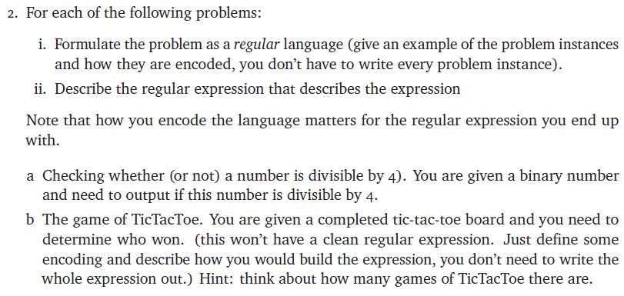

Answer:

(a) Since the binary numbers divisible by 4 all have 00 as their last two digits, we might define the regular language $L_{A}$ as:

Base Case:

(1) $00∈L_{A}$

Inductive Step:

(2) $0w∈L_{A}$, if $w∈L_{A}$

(3) $1w∈L_{A}$, if $w∈L_{A}$

For example, the binary expression of 52 is 10100, and we could construct it by:

00 🡪 Rule (1)

100 🡪 Rule (3)

0100 🡪 Rule (2)

10100 🡪 Rule (3)

Therefore, we could obtain a regular expression of the language as ${\left(0+1\right)}^{*}00$

(b)

There should be 8 scenarios for a player to win in a tic-tac-toe game (if it’s not an unreachable game e.g. # of x - # of o > 1 or # of x - # of o < 0, we do not consider these scenarios in this problem): 3 row win scenarios, 3 column win scenarios, and 2 wins in diagonals. After defining a language which includes all strings representing the winning scenarios, we simply need to find the regular expressions of strings satisfying these winning scenarios.

When encoding the board to a string, we use the following sequence on the board to form the string:

|  |  |  |
| --- | --- | --- |
| 1 | 2 | 3 |
| 4 | 5 | 6 |
| 7 | 8 | 9 |

Using 0 to represent empty, 1 to represent “x”, 2 to represent “o”.

So, the 8 situations could be denoted as:

Row wins:

$aaa(0+1+2) (0+1+2) (0+1+2) (0+1+2) (0+1+2) (0+1+2)$,

$(0+1+2) (0+1+2) (0+1+2)aaa(0+1+2) (0+1+2) (0+1+2)$,

$(0+1+2) (0+1+2) (0+1+2) (0+1+2) (0+1+2) (0+1+2)aaa$

Columns Wins:

$a(0+1+2) (0+1+2)a(0+1+2) (0+1+2)a(0+1+2) (0+1+2)$,

$(0+1+2)a(0+1+2) (0+1+2)a(0+1+2) (0+1+2)a(0+1+2)$,

$(0+1+2) (0+1+2)a(0+1+2) (0+1+2)a(0+1+2) (0+1+2)a$

Diagonal Wins:

$a(0+1+2) (0+1+2) (0+1+2)a(0+1+2) (0+1+2) (0+1+2)a$,

$(0+1+2) (0+1+2)a(0+1+2)a(0+1+2)a(0+1+2) (0+1+2)$

where a is 1 or 2 in one expression.

To judge who win, we just need to find the string represent the board belongs to which situation in those 8 situations, and the winner is the person whose mark represents the a in the situation.